## Sierran Mixed Conifer (SMC)

### General Information

### Cover Type Overview

**Sierran Mixed Conifer (SMC)**

* 297,226.47 acres / 120,283.47 hectares
* Crosswalk to EVeg: Regional Dominance Type 1
  + Mixed Conifer – Fir
  + Mixed Conifer – Pine
* Crosswalk to EVeg: Regional Dominance Type 2
  + Any
* Crosswalks for Modifiers
  + Mesic
    - BpS Model: 0610280 Mediterranean California Mesic Mixed Conifer Forest and Woodland
    - Presettlement Fire Regime Type: Moist Mixed Conifer
    - Intersects with modeled “mesic” end of the biophysical spectrum
  + Xeric
    - BpS Model: 0610270 Mediterranean California Dry-Mesic Mixed Conifer Forest and Woodland
    - Presettlement Fire Regime Type: Dry Mixed Conifer
    - Intersects with modeled “xeric” end of the biophysical spectrum
  + Ultramafic
    - This type is created by intersecting an ultramafic soils/geology layer with the existing vegetation layer. Where cells intersect with SMC they are assigned to the ultramafic modifier.

**Sierran Mixed Conifer with Aspen (SMC-ASP)**

* 150.34 acres / 60.84 hectares
* Crosswalks for Modifers
  + None: This type is created by overlaying the NRIS TERRA Inventory of Aspen on top of the EVeg layer. Where it intersects with SMC it is assigned to SMC-ASP

### Vegetation Description

**Sierran Mixed Conifer (SMC)** The Sierran mixed conifer (SMC) landcover type is typically composed of three or more conifers, sometimes mixed with hardwoods. In forest experiencing the natural fire regime, stand and landscape structure are both highly heterogeneous, and age structure is usually uneven. Past management (e.g., logging and fire suppression) and its effects on forest succession have resulted in greater structural homogeneity and a dramatic increase in the presence of shade tolerant/fire intolerant tree species. Old-growth stands where fire has been excluded are often multi-storied, with the overstory comprised of various species (often dominated by pines) and the understory dominated by *Abies concolor* and *Calocedrus decurrens*. In the absence of fire, forested stands can form closed, multilayered canopies with over 100% overlapping cover. Such dense stands were probably relatively uncommon before settlement, and found in moist microsites, on north slopes, and at higher elevations. When openings occur, shrubs are common in the understory. SMC forest was dominated by open stand conditions and old forest before Euroamerican settlement, but today closed canopy conditions dominated by middle aged trees are more common. Even aged stands are also widespread (Allen 2005).

Five conifers and one hardwood typify the SMC forest: *A. concolor*, *Pseudotsuga menziesii*, *Pinus ponderosa*, *Pinus lambertiana*, *C. decurrens*, and *Quercus kelloggii*. *A. concolor* tends to be the most ubiquitous species because it is the competitive dominant in the SMC forest type. White fir tolerates shade, reproduces prolifically in the absence of fire, and has the ability to survive long periods of overtopping in brush fields. *P. menziesii* replaces white fir as the competitive dominant at lower elevations and in the northern Sierra Nevada. *P. ponderosa* which was historically the dominant species in SMC forest, still dominates much of the SMC forest at lower elevations and on south slopes; like sugar pine, its densities have been much reduced by logging. *Pinus jeffreyi* commonly replaces *P. ponderosa* at high elevations, on cold sites, or on ultramafic soils. *Abies magnifica* is a minor associate at the highest elevations, as are *Pinus monticola* and *Pinus contorta* ssp. *murrayana*. *P. lambertiana* is found throughout the SMC type, but its densities have been much reduced by selective logging and white pine blister rust. *Q. kelloggii* is a common component in SMC stands on warm, dry sites. It sprouts prolifically after fire, and although it does best on open sites, it is maintained under adverse conditions such as overtopping by conifers and thin soils (Allen 2005). In some locations, *Populus tremuloides* is also a component of the stand and, when present, typically dominates during the early seral stages following disturbance.

*Ceanothus, Arctostaphylos*, *Chrysolepis*, *Prunus*, *Ribes*, *Rosa*, and *Chamaebatia* are common shrub genera in the SMC understory (Allen 2005). Grasses and forbs are diverse but rarely contribute much cover, except where stand structure is open.

* **Mesic Modifer** The primary species associated with mesic sites are *A. concolor*, *P. menziesii, C. decurrens, and P. lambertiana*. *P. contorta* ssp. *murrayana* may also be associated with mesic forests at higher elevations. As elevations begin to increase, *A. magnifica* becomes more prominent. *Lithocarpus densiflora* is an indicator of lower elevation sites with high water availability, either from meteoric or surface water.

Understory diversity is often low in these sites, as high canopy cover and tree density reduce solar incidence at the soil surface. Very often the ground is covered in thick litter and duff. Some shade tolerant shrub and herb species occur.

* **Xeric Modifier** Xeric sites are characterized by the presence of shade intolerant/fire tolerant conifer species such as *P. ponderosa*, *P. jeffreyi*, and *P. lambertiana*, as well as the occurrence of varying amounts of more shade tolerant species like *A. concolor* and *C. decurrens* *Q. kelloggii* is locally common. The pines normally are prominent on south and west facing slopes, *A. concolor* and sometimes *P. menziesii* on north and east slopes, and *C. decurrens* as a secondary component on all slopes. At lower elevations, *Pinus sabiniana*, and *Quercus chrysolepis* may become common associates. Understory shrubs include *Ceanothus, Arctostaphylos*, *Chamaebatia,* and *Artemisia* and *Purshia* in dry, eastern sites.
* **Ultramafic Modifier** Ultramafic soils, found primarily in the northern mixed conifer zone, support a number of endemic plant species. Slowly growing and often stunted *P. contorta* ssp. *murrayana* and *P. jeffreyi* occur in combinations or in nearly pure open stands. Other tree associates on ultramafics include *P. menziesii*, *C. decurrens,* and *Pinus attenuata*. Hardwoods are usually sparse, but shrubs such as *Arctostaphylos*, *Quercus*, *Rhamnus*, *Lithocarpus*, *Rhododendron,* and *Ceanothus* may occur on these sites. Often, a dramatic landscape shift occurs across abrupt discontinuities between ultramafics and other rock types.. For example, regional stands of dense conifer forests are replaced by stunted and open stands of other conifers, by chaparral or even by barrens on which woody vegetation is absent (“CalVeg Zone 1” 2011).

**Sierran Mixed Conifer with Aspen (SMC-ASP)** When *P. tremuloides* co-occurs with SMC on the west side of the crest, it is typically found in smaller patches, often less than 2 ha (5 acres) in size. This variant is not subject to the modifiers described above because it is only found on mesic sites. Mature stands in which *P. tremuloides* are still dominant are usually relatively open. Average canopy closures of stands in eastern California range from 60 to 100 percent in young and intermediate-aged stands and from 25 to 60 percent in mature stands. The open nature of the stands results in substantial light penetration to the ground (Verner 1998).

### Distribution

**Sierran Mixed Conifer** SMC generally forms a vegetation band ranging from 500 to 2000 m (1500 to 6500 ft). It dominates the western middle elevation slopes of the Sierra Nevada. Soils supporting SMC are varied in depth and composition, and are derived primarily from Mesozoic granitic, Paleozoic metamorphic rocks, and Cenozoic volcanic rocks (Allen 2005).

* **Mesic Modifer** Generally found on favorable slopes, primarily north and east aspects throughout the geographic range, as well as along streams in drier areas. It is more common at higher elevations as compared to the xeric type. (“CalVeg Zone 1” 2011)
* **Xeric Modifier** Occurs on south and west-facing aspects (Landfire 2007b). At lower elevations patches may be found on north slopes. At higher elevations this landcover type most typically occurs on south, east and west aspects.
* **Ultramafic Modifier**  Ultramafics have been mapped at various spatial densities throughout the elevational range of the Sierran Mixed Conifer landcover type. Low to moderate elevations in ultramafic and serpentinized areas often produce soils low in essential minerals like calcium potassium, and nitrogen, and have excessive accumulations of heavy metals such as nickel and chromium. These sites vary widely in the degree of serpentinization and effects on their overlying plant communities (“CalVeg Zone 1” 2011). Typically, this type occurs on north facing concave slopes or toe slopes with thin layers of ultramafic rocks. Note, the terms “ultramafic rock” and “serpentine” are broad terms used to describe a number of different but related rock types, including serpentinite, peridotite, dunite, pyroxenite, talc and soapstone, among others (O’Geen et al. 2007)

**Sierran Mixed Conifer with Aspen** Sites supporting *P. tremuloides* are usually associated with added soil moisture, i.e., azonal wet sites. These sites are found throughout the SMC zone, but are often close to streams and lakes. Other sites include meadow edges, rock reservoirs, springs and seeps. Terrain can be simple to complex. At lower elevations, topographic conditions for this type tends toward positions resulting in relatively colder, wetter conditions within the prevailing climate, e.g., ravines, north slopes, wet depressions, etc. (Landfire 2007c).

**Disturbances**

### Wildfire

**Sierran Mixed Confier** Wildfires are common and frequent; mortality depends on vegetation vulnerability and wildfire intensity. Low-mortality fires kill small trees and may consume above-ground portions of small oaks, shrubs and herbs, but do not kill large trees or below-ground organs of most oaks, shrubs and herbs which promptly re-sprout. High-mortality fires kill trees of all sizes and may kill many of the shrubs and herbs as well. However, high-mortality fires typically kill only the above-ground portions of the oaks, shrubs and herbs; consequently, most oaks, shrubs and herbs promptly re-sprout from surviving below-ground organs.

Data on fire return intervals (FRIs) are available from a few review papers. Skinner and Chang (1996) aggregated FRIs from the Sierra Nevada and separated pre-1850 data from total data. Van de Water and Safford’s 2011 review paper aggregates hundreds of articles, conference proceedings, and Landfire data on fire return intervals, with an emphasis on Californian sources. We also include here data from the pertinent Landfire BpS models (2007a, 2007b, 2007c, 2007d).

* **Mesic Modifier** For moist mixed conifer forests, Van de Water and Safford (2011) found a mean fire return interval of 16 years, median of 12 years, mean min interval of 5 years and mean max of 80 years. Skinner and Chang (1996) found for Douglas-fir–mixed conifer types in the Klamath mountains a median FRI of 15 years, with a minimum of 3-12 years and a maximum of 18-59 years. Numbers for White fir–mixed conifer types were taken from studies in the Southern Cascades, Central Sierra, and Southern Sierra. Median FRI was about 12 years, with a minimum of 4 years and a maximum ranging from 24-35 years. Landfire’s Mediterranean California Mesic Mixed Conifer Forest and Woodland for the northern Sierra estimated fire intervals of 150 years for replacement fire, 45 years for mixed fire, and 35 years for surface fire, with an overall interval of 17 years (2007a). We recalculated these numbers using condition-specific information and using only high and low mortality fire categories, which resulted in an interval of 150 years for high mortality fire, 15 years for low mortality fire, and 17 years for any fire.
* **Xeric Modifier** For dry mixed conifer forests, Van de Water and Safford (2011) found a mean fire return interval of 11 years, median of 9 years, mean min interval of 5 years and mean max of 50 years. Skinner and Chang (1996) found for Ponderosa pine–mixed conifer types in the Southern Sierra and Klamath Mountains a median FRI of 11, with a minimum of 4 years and a maximum ranging from 14-46 years. Landfire’s Mediterranean California Dry-Mesic Mixed Conifer Forest and Woodland for the northern Sierra estimated fire intervals of 150 years for replacement fire, 35 years for mixed fire, and 17 years for surface fire, with an overall interval of 11 years (2007b). We recalculated these numbers using condition-specific information and using only high and low mortality fire categories, which resulted in an interval of 175 years for high mortality fire, 13 years for low mortality fire, and 12 years for any fire.
* **Ultramafic Modifier** Skinner and Chang (1996) reported fire intervals for *P. jeffreyi* in the Klamath Mountains. They found a median FRI of 13 years, with a minimum of 4 and a maximum of 157. This is a surprisingly short FRI, but these results are consistent with the general consensus that fire intervals on ultramafic sites are somewhat longer (due to lower productivity) and more variable than on adjacent non-ultramafic sites. Safford (pers. commun.) suggests that the mean FRI is somewhat longer than reported here, perhaps 20-40 years. The Landfire model for Klamath-Siskiyou Upper Montane Serpentine Mixed Conifer Woodland (2007d) gave an overall mean FRI of 10 years, which is likely too short. Most fires are predicted to be low mortality surface fires occurring frequently, about every 12 years ranging from 3-35 years. High mortality fires were modeled to recur between 100 and 400 years, with a mean FRI of 250 years.

**Sierran Mixed Conifer with Aspen** Sites supporting *P. tremuloides* are maintained by stand replacing disturbances that allow regeneration from below-ground suckers. Upland clones are impaired or eliminated by conifer ingrowth and overtopping and intenstive grazing that inhibits growth. If aboveground *P. tremuloides* on upland sites disappears completely (site overtaken by conifers) due to prolonged absence of disturbance (perhaps >200 years), then restoration to a *P. tremuloides* condition is not a viable pathway. In a reference condition scenario, a few stands will advance toward conifer dominance, but in the current landscape scenario where fire has been reduced from reference conditions there are many more conifer-dominated mixed aspen stands (Verner 1998).

For aspen, Van de Water and Safford (2011) found a mean fire return interval of 19 years, median of 20 years, mean min interval of 10 years and mean max of 90 years. The LandFire model for northern Sierra Nevada aspen that is seral to conifers generated a mean return interval of 94 years for high mortality fire, 58 years for low mortality fire, and 36 years overall (LandFire 2007c).

Table 1. SMC, SMC-ASP Fire return intervals (years) and percentage of high versus low mortality fires in relation to soil type modifier and the presence of *P. tremuloides* (Aspen). Numbers for SMC on mesic sites were derived from BpS model 0610280 (Landfire 2007a) and Van de Water and Safford (2011). Numbers for SMC on xeric sites were derived from BpS model 0610270 (Landfire 2007b) and Van de Water and Safford (2011). Numbers for SMC on ultramafic sites were derived from BpS model 0310220 (Landfire 2007d). Numbers for SMC-ASP were derived from BpS model 0610610 (Landfire 2007c) and Van de Water and Safford (2011).

|  |  |  |  |  |  |  |
| --- | --- | --- | --- | --- | --- | --- |
| **Variant** | **Modifier** | **Fire Severity** | **Average** | **Min** | **Max** | **% of Fires** |
| SMC | Mesic | High | 150 | -- | -- | 15 |
| Low | 15 | -- | -- | 85 |
| All Fires | 17 | 5 | 80 | 100 |
| Xeric | High | 175 | -- | -- | 8 |
| Low | 13 | -- | -- | 92 |
| All Fires | 12 | 5 | 60 | 100 |
| Ultramafic | High | 250 | -- | -- | 18 |
| Low | 40 | -- | -- | 82 |
| All Fires | 30 | 4 | 157 | 100 |
| SMC-ASP | n/a | High | 99 | -- | -- | 37 |
| Low | 58 | -- | -- | 63 |
| All Fires | 20 | 5 | 90 | 100 |

### Other Disturbance

Other disturbances are not currently modeled, but may, depending on the condition affected and mortality levels, reset patches to early development, maintain existing stages, or shift/accelerate succession to a more open stage. All of the tree species associated with this vegetation type are susceptible to a wide variety of pathogens and insects.

### Vegetation Condition Classes

### Sierran Mixed Conifer Variant

### Early Development (ED)

##### Description This condition is characterized by the recruitment of a new cohort of early successional tree species into an open area created by a stand-replacing disturbance. After disturbance, succession proceeds from an ephemeral herb to perennial grass-herb community. This stage is generally only only a few years long and progresses to a shrub-seedling-sapling stage dominated by any of the following genera: *Arctostaphylos*, *Ceanothus,* *Prunus*, *Ribes*, and *Chamaebatia,* as well as *Q. vaccinifolia*. Tree seedlings/saplings typical of the cover type can be either high or low density depending on local environmental conditions and climate conditions following the disturbance.

##### In some cases (e.g., favorable climate conditions following the stand-replacing disturbance and a good seed source), tree seedlings may develop a nearly continuous canopy and succeed relatively quickly to mid-development conditions. In other cases, and more commonly on xeric or ultramafic sites, chaparral conditions may dominate and persist for long periods of time (LandFire 2007a, LandFire 2007b).

##### Succession Transition

* 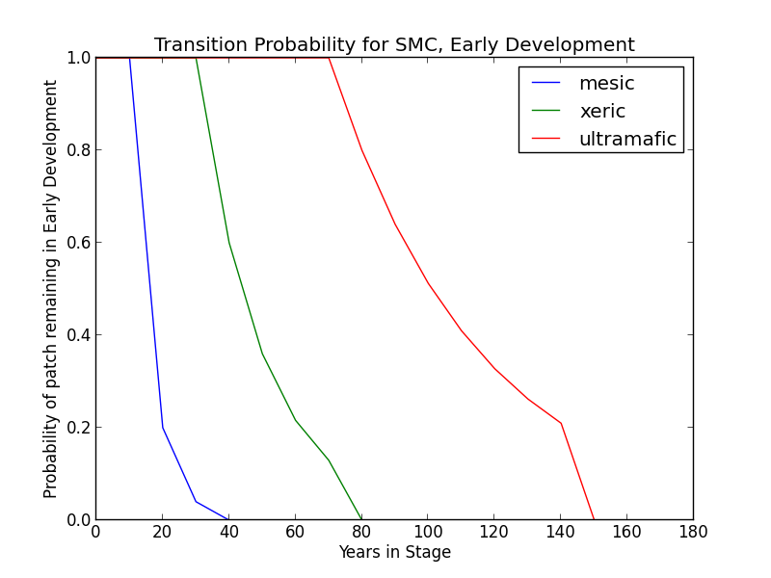**Mesic Modifier** In the absence of disturbance, this class will begin transitioning to a mid development stage after 20 years. The probability of succession per time step is 0.8. The transition may be to either MDC or MDO, although the transition to MDC is twice as likely as transition to MDO. At 40 years, all stands will have succeeded to either MDC or MDO.
* **Xeric Modifier** Transition to the MD conditions may be substantially delayed. Thus, in the absence of disturbance, this class will begin transitioning to MDO after 40 years and may be delayed in the ED stage for as long as 80 years. During this period, the probability of succession per time step is 0.4.
* **Ultramafic Modifier** Transition to the MD condition may be substantially delayed. Thus, in the absence of disturbance, this class will begin transitioning to MDO after 80 years and may be delayed in the ED stage for as long as 150 years. During this period, the probability of succession per time step is 0.2.

##### Wildfire Transition High mortality wildfire (100% of fires in this stage) recycles the patch through the Early Development stage. Low mortality wildfire is not modeled for this stage.

### Mid Development - Open (MDO)

##### Description Heterogeneous ground cover of grasses, forbs, and shrubs.Trees present are pole to medium sized conifers with canopy cover less than 50% (Landfire 2007a). Conifer species likely present include *A. concolor, C. decurrens P. ponderosa, P. menziesii, and P. lambertiana*. Pines predominate on xeric sites while firs predominate on mesic sites. *Q. kelloggi* may occur as well, mostly on warmer slopes and where soils are less productive (Landfire 2007a). Ultramafic sites will have similar species composition, especially at edges, but *P. jeffreyi*, and *C. decurrens* are relatively more common (O’Geen et al. 2007).

##### Succession Transition

* 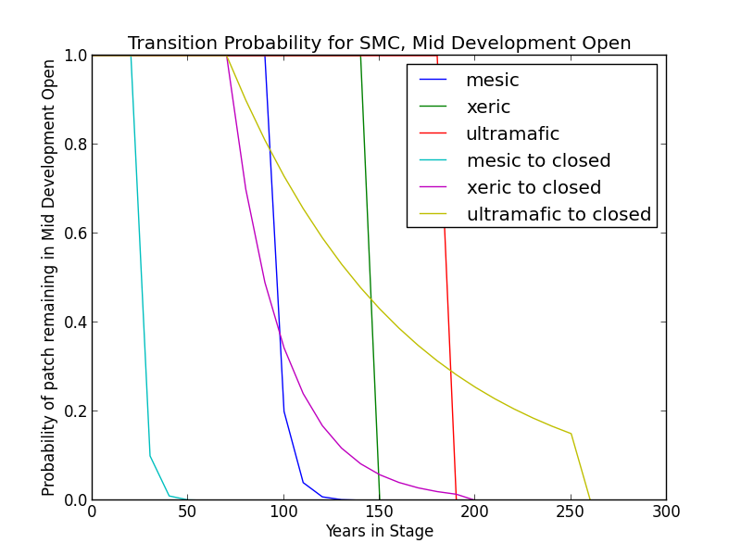**Mesic Modifier**  In the absence of low mortality disturbance, MDO will begin transitioning to MDC after 30 years at a rate of 90%. Succession to LDO takes place variably after 100 years since entering a middle development condition, at a rate of 0.8. All patches succeed by 150 years in MD.
* **Xeric Modifier** In the absence of low mortality disturbance, MDO will begin transitionin to MDC after 80 years at a rate of 30%. Succession to LDO takes place variably beginning at 160 years (60% chance) since transition to middle development, and all patches succeed by 200 years.
* **Ultramafic Modifier** In the absence of low mortality disturbance, MDO will begin transitioning to MDC after 80 years at a rate of 10%. Succession to LDO takes place variably beginning at 200 years (60% chance) since transition to middle development, and all patches succeed by 260 years.

##### Wildfire Transition

* **Mesic Modifier** High mortality wildfire (9.5% of fires) returns the patch to Early Development. Low mortality fire (90.5%) maintains the MDO condition and allows for succession to LDO.
* **Xeric Modifier** High mortality wildfire (8.6% of fires) returns the patch to Early Development. Low mortality fire (91.4%) maintains the MDO condition and allows for succession to LDO.
* **Ultramafic Modifier** High mortality wildfire (5.6% of fires) returns the patch to Early Development. Low mortality fire (94.4%) maintains the MDO condition and allows for succession to LDO.

##### Mid Development – Closed (MDC)

##### Description Sparse ground cover of grasses, forbs, and shrubs; moderate to dense cover of trees. Conifers are pole to medium-sized, with canopy cover from 50-100%. Conifer species likely present include *A. concolor, C. decurrens, P. ponderosa, P. menziesii*, and *P. lambertiana*. *Q. kelloggi* may occur as well, mostly on warmer slopes and where soils are less productive (Landfire 2007a, Landfire 2007b). Ultramafic sites will have similar species composition, especially at edges, but *P. jeffreyi,* and *C. decurrens* are relatively more common (O’Geen et al. 2007).

##### Succession Transition

* 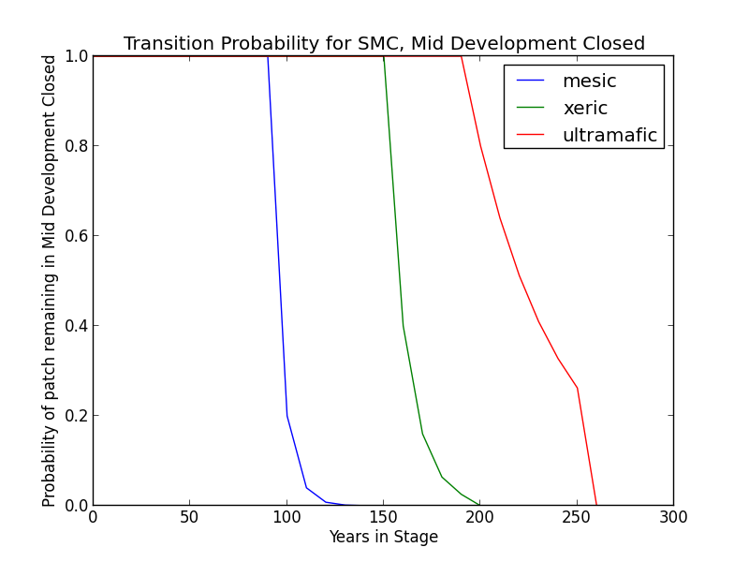**Mesic Modifier**  MDC persists for a minimum of 100 years in the absence of fire, at which point stands succeed at a rate of 0.8 to LDC. All patches succeed by 150 years in MD. Stands that transitioned to MDC from MDO begin transitioning to LDC once the time since transition to a mid development stage is at least 100 years.
* **Xeric Modifier** Transition to late seral conditions may be delayed. Thus, in the absence of disturbance, this class will begin transitioning to LDC after 160 years at a rate of 0.6 per time step and may be delayed in the MDC stage for up to 200 years.
* **Ultramafic Modifier** Transition to late seral conditions may be substatially delayed. Thus, in the absence of disturbance, this class will begin transitioning to LDC after 200 years at a rate of 20% per time step and may be delayed in the MDC stage for up to 260 years.

##### Wildfire Transition

* **Mesic Modifier** High mortality wildfire (11% of fires) returns the patch to ED. Low mortality wildfire (88%) opens the stand up to MDO 41.3% of the time; otherwise, the patch remains in MDC. Past low severity may affect other variables, such as susceptibility to fire and likelihood of succession?
* **Xeric** **Modifier** High mortality wildfire (14.6% of fires) returns the patch to ED. Low mortality wildfire (85.4%) opens the stand up to MDO 51.4% of the time; otherwise, the patch remains in MDC. Past low severity may affect other variables, such as susceptibility to fire and likelihood of succession?
* **Ultramafic Modifier** High mortality wildfire (5.3% of fires) returns the patch to ED. Low mortality wildfire (94.7%) opens the stand up to MDO 7.4% of the time; otherwise, the patch remains in MDC.

### Late Development – Open (LDO)

##### Description Heterogenous ground cover of grasses, forbs, and low shrubs; low density (less than 50% canopy cover) of large trees. Occurring in small to moderately-sized patches on southerly aspects and ridge tops. Upper canopy trees may be very large, but overall size classes vary with a patchy distribution and open canopy. This condition develops when low-mortality disturbance is fairly frequent; it persists as long as low-mortality fires continue to occur periodically. Conifer species likely present include *A. concolor, C. decurrens, P. ponderosa, P. menziesii*, and *P. lambertiana*. *Q. kelloggi* may occur as well, mostly on warmer slopes and where soils are less productive (Landfire 2007a, LandFire 2007b). Ultramafic sites will have similar species composition, especially at edges, but *P. jeffreyi,* and *C. decurrens* are relatively more common (O’Geen et al. 2007).

##### Succession Transition

* 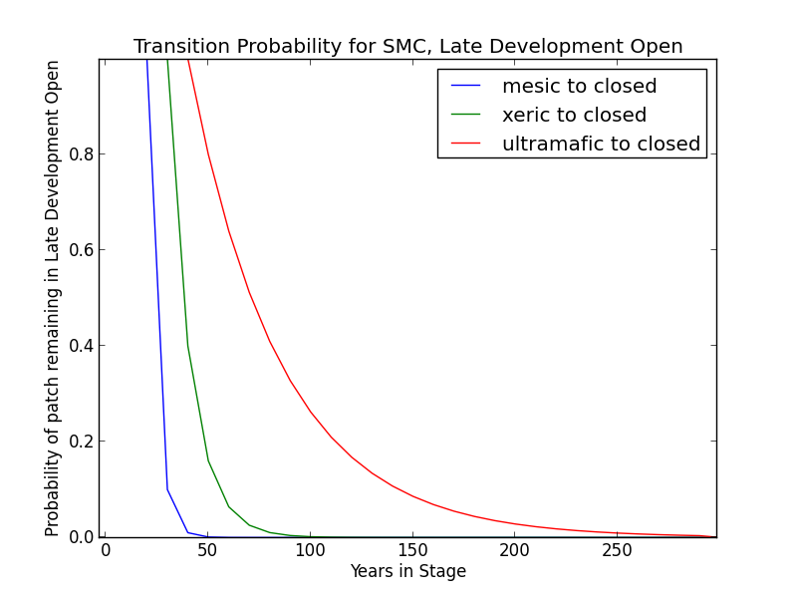**Mesic Modifier**  In the presence of low mortality disturbance, this condition can self-perpetuate, but after 30 years with no fire, patches in this condition will begin transitioning to LDC at a rate of 0.9 per time step.
* **Xeric Modifier** Succession to LDC may occur after 40 years with no fire; the probability is 0.6 per time step.
* **Ultramafic Modifier** Patches occurring on ultramafic soils may succeed to LDC after 50 years with no fire, but the probability is just 0.2 per time step.

##### Wildfire Transition

* **Mesic Modifier** High mortality wildfire (3.6% of fires) returns the patch to early development. Low mortality wildfire (90.5%) maintains LDO.

**Xeric Modifier** High mortality wildfire (2.5% of fires) returns the patch to early development. Low mortality wildfire (97.5%) maintains LDO.

* **Ultramafic Modifier** High mortality wildfire (2.3% of fires) returns the patch to early development. Low mortality wildfire (97.7%) maintains LDO.

### Late Development – Closed (LDC)

**Description** Overstory of large and very large trees with canopy cover over 50%. Understory characterized by medium and smaller-sized shade-tolerant conifers (Landfire 2007a). Conifer species likely present include *A. concolor, C. decurrens, P. ponderosa, P. menziesii*, and *P. lambertiana*. *Q. kelloggi* may occur as well, mostly on warmer slopes and where soils are less productive (Landfire 2007a, LandFire 2007b). Ultramafic sites will have similar species composition, especially at edges, but *P. jeffreyi,* and *C. decurrens* are relatively more common (O’Geen et al. 2007).

Areas with aspen are now overtopped by conifers. Some decadent aspen can continue to persist but without disturbance the clone will not replace itself.

##### Succession Transition In the absence of disturbance, this class will maintain, regardless of soil characteristics.

##### Wildfire Transition

* **Mesic Modifier** High mortality wildfire (31.2% of fires) will return the patch to Early Development. Low mortality wildfire (68.8%) usually has little effect, although 29.9% of the time it opens the stand up to LDO.
* **Xeric Modifier** High mortality wildfire (34% of fires) will return the patch to Early Development. Low mortality wildfire (66%) usually has little effect, although 7.6% of the time it opens the stand up to LDO.
* **Ultramafic Modifier** High mortality wildfire (10% of fires) will return the patch to Early Development. Low mortality wildfire (90%) usually has little effect, although 7.4% of the time it opens the stand up to LDO.

### Aspen Variant

### Early Development – Aspen (ED–A)

**Description** Grasses, forbs, low shrubs, and sparse to moderate cover of tree seedlings/saplings (primarily *P. tremuloides*) with an open canopy. This condition is characterized by the recruitment of a new cohort of early successional, shade-intolerant tree species into an open area created by a stand-replacing disturbance.

Following disturbance, succession proceeds rapidly from an herbaceous layer to shrubs and trees, which invade together. *P. tremuloides* suckers over 6ft tall develop within about 10 years (LandFire 2007c).

**Succession Transition** Unless it burns, a patch in the early stage persists for 10 years, at which point it transitions to MDC-A.

**Wildfire Transition** High mortality wildfire (100% of fires) recycles the patch through the Early Development – Aspen stage. Low mortality wildfire is not modeled for this stage.

### Mid Development – Aspen (MD–A)

##### Description *P. tremuloides* trees 5-16in DBH. Canopy cover is highly variable, and can range from 40-100%. These patches range in age from 10 to 150 years and could maintain indefinitely. Some understory conifers, including *P. ponderosa*, *P. lambertiana*, and *A. concolor* are encroaching, but *P. tremuloides* is still the dominant component of the stand (Landfire 2007c).

##### Succession Transition MD-A persists for at least 50 years in the absence of fire, after which stands begin transitioning to MD-AC at a rate of 0.7 per timestep. At age 100 all remaining MD-A patches transition to MD-AC.

##### Wildfire Transition High mortality wildfire (100% of fires) recycles the patch through the Early Development – Aspen stage. Low mortality wildfire is not modeled for this stage.

**Mid Development – Aspen with Conifer (MD–AC)**

**Description** These stands have been protected from fire for at least 100 years. *P. tremuloides* trees are predominantly 16in DBH and greater. Conifers are present and overtopping the *P. tremuloides*. *A. concolor* is a typical conifer that is successional to *P. tremuloides*, and is depicted here, but other conifers including *P. ponderosa* and *P. lambertiana* are also possible. Conifers are pole to medium-sized, and conifer cover is at least 40% (Landfire 2007c).

**Succession Transition** MD-AC persists for 100 years in the absence of fire, after which stands transition to LDC.

**Wildfire Transition** High mortality wildfire (28.4% of fires) returns the patch to ED-A. Low mortality wildfire (71.6%) maintains the patch in MD- AC.

### Late Development – Closed (LDC)

**Description** Some *P. tremuloides* continue to be present in the understory, but large conifers are now the dominant tree species, having overtopped the *P. tremuloides.* Smaller conifers are present in the midstory as well. Conifer species likely present include *A. concolor, C. decurrens, P. ponderosa, P. menziesii*, and *P. lambertiana*. (Landfire 2007a, LandFire 2007b, Landfire 2007c).

##### Succession Transition See description of same stage under Sierran Mixed Conifer Variant

##### Wildfire Transition High mortality wildfire (31.2% of fires) will return the patch to Early Development - Aspen. Low mortality wildfire (68.8%) maintains the current condition.

**Late Development – Fire-Maintained Aspen with Conifer (LD–FMAC)**

**Description** If stands are sufficiently protected from fire such that conifer species overtop *P. tremuloides* and become large, they may be able to withstand some fire that more sensitive *P. tremuloides* cannot. When this occurs, it creates a patch characterized by late development conifers, such as *A. concolor, P. ponderosa,* or *P. lambertiana*, and early seral *P. tremuloides*.

**Succession Transition** LD-FMAC persists for 70 years in the absence of fire, after which stands transition to LDC.

**Wildfire Transition** High mortality wildfire (9% of fires) returns the patch to ED-A. Low mortality wildfire (91%) maintains the stand in LD-FMAC. [Note, recently added and relative fire probabilities have not been recalculated to include this stage.]

**Condition Classification**

Table 2. Classification of cover condition for SMC. Diameter at Breast Height (DBH) and Cover From Above (CFA) values taken from EVeg polygons. DBH categories are: null, 0-0.9”, 1-5.9”, 5-9.9”, 10-19.9”, 20-29.9”, 30”+. CFA categories are null, 0-10%, 10-20%, … , 90-100%. Each row in the table below should be read with a boolean AND across each column.

|  |  |  |  |  |  |
| --- | --- | --- | --- | --- | --- |
| Cover Condition | Overstory Tree  Diameter 1 (DBH) | Overstory Tree  Diameter 2 (DBH) | Total Tree  CFA (%) | Conifer  CFA (%) | Hardwood  CFA (%) |
| Early All | null | any | any | any | any |
| Early All | 0-5.9” | any | any | any | any |
| Mid Open | 5-19.9” | any | null | null | null |
| Mid Open | 5-19.9” | any | <50 | any | any |
| Mid Open | 5-19.9” | any | null | <50 | null |
| Mid Closed | 5-19.9” | any | >50 | any | any |
| Mid Closed | 5-19.9” | any | null | >50 | any |
| Late Closed | 20”+ | any | >50 | any | any |
| Late Closed | 20”+ | any | null | >50 | any |
| Late Open | 20”+ | any | null | null | null |
| Late Open | 20”+ | any | <50 | any | any |
| Late Open | 20”+ | any | null | <50 | null |

Table 3. Classification of cover condition for SMC-ASP. Diameter at Breast Height (DBH) and Cover From Above (CFA) values taken from EVeg polygons. DBH categories are: null, 0-0.9”, 1-5.9”, 5-9.9”, 10-19.9”, 20-29.9”, 30”+. CFA categories are null, 0-10%, 10-20%, … , 90-100%. Each row in the table below should be read with a boolean AND across each column.

|  |  |  |  |  |  |
| --- | --- | --- | --- | --- | --- |
| Cover Condition | Overstory Tree  Diameter 1 (DBH) | Overstory Tree  Diameter 2 (DBH) | Total Tree  CFA (%) | Conifer  CFA (%) | Hardwood  CFA (%) |
| Early All | 0-5.9” | any | any | any | any |
| Mid Aspen | 5-9.9” | any | null | null | null |
| Mid Aspen | 5-9.9” | any | <50 | any | any |
| Mid Aspen-  Conifer | 10-19.9” | any | >50 | any | any |
| Mid Aspen-  Conifer | 10-19.9” | any | null | >50 | any |
| Late Closed | 20”+ | any | >50 | any | any |
| Late Closed | 20”+ | any | null | >50 | any |
| Fire-Maintained  Aspen-Conifer | 20”+ | any | null | null | null |
| Fire-Maintained  Aspen-Conifer | 20”+ | any | <50 | any | any |

**Draft Model**

(See PDF) Disturbance-Succession model for SMC and SMC-ASP

**References**

Allen, Barbara H. “Sierran Mixed Conifer (SMC).” *A Guide to Wildlife Habitats of California*. 1988, updated 2005. Mayer, Kenneth E. and Laudenslayer, William F., eds.California Deparment of Fish and Game. <http://www.dfg.ca.gov/biogeodata/cwhr/pdfs/SMC.pdf>. Accessed 4 December 2012.

“CalVeg Zone 1.” Vegetation Descriptions. *Vegetation Classification and Mapping*. 11 December 2008. U.S. Forest Service. <http://www.fs.usda.gov/Internet/FSE_DOCUMENTS/fsbdev3_046448.pdf>. Accessed 2 April 2013.

LandFire. “Biophysical Setting Models.” Biophysical Setting 0610280. 2007a. LANDFIRE Project, U.S. Department of Agriculture, Forest Service; U.S. Department of the Interior. <http://www.landfire.gov/national_veg_models_op2.php>. Accessed 9 November 2012.

LandFire. “Biophysical Setting Models.” Biophysical Setting 0610270. 2007b. LANDFIRE Project, U.S. Department of Agriculture, Forest Service; U.S. Department of the Interior. <http://www.landfire.gov/national_veg_models_op2.php>. Accessed 9 November 2012.

LandFire. “Biophysical Setting Models.” Biophysical Setting 0610610. 2007c. LANDFIRE Project, U.S. Department of Agriculture, Forest Service; U.S. Department of the Interior. <http://www.landfire.gov/national_veg_models_op2.php>. Accessed 7 January 2013.

LandFire. “Biophysical Setting Models.” Biophysical Setting 0711700. 2007d. LANDFIRE Project, U.S. Department of Agriculture, Forest Service; U.S. Department of the Interior. <http://www.landfire.gov/national_veg_models_op2.php>. Accessed 30 November 2012.

O’Geen, Anthony T., Dahlgren, Randy A., and Sanchez-Mata, Daniel. “California Soils and Examples of Ultramafic Vegetation.” Barbour, Michael, Keeler-Wolf, Todd, and Schoenherr, Allan A., eds. *Terrestrial Vegetation of California, 3rd Edition*. 2007. pp. 71-106.

Skinner, Carl N. and Chang, Chi-Ru. “Fire Regimes, Past and Present.” *Sierra Nevada Ecosystem Project: Final report to Congress, vol. II, Assessments and scientific basis for management options*. Davis: University of California, Centers for Water and Wildland Resources, 1996.

Van de Water, Kip M. and Safford, Hugh D. “A Summary of Fire Frequency Estimates for California Vegetation Before Euro-American Settlement.” *Fire Ecology* 7.3 (2011): 26-57. doi: 10.4996/fireecology.0703026.

Verner, Jared. “Aspen (ASP).” *A Guide to Wildlife Habitats of California*. 1988. Mayer, Kenneth E. and Laudenslayer, William F., eds. California Department of Fish and Game. <http://www.dfg.ca.gov/biogeodata/cwhr/pdfs/SMC.pdf>. Accessed 4 December 2012.